Lab Assignment 5.1 and 6
2303a51019

Task 1:
Employee Data: Create Python code that defines a class named `Employee` with the following attributes: `empid`, `empname`, `designation`, `basic_salary`, and `exp`. Implement a method
`display_details()` to print all employee details. Implement another method
`calculate_allowance()` to determine additional allowance based on experience: If `exp > 10 years` → allowance = 20% of `basic_salary`
If `5 ≤ exp ≤ 10 years` → allowance = 10% of `basic_salary` If `exp < 5 years` → allowance = 5% of `basic_salary`
Finally, create at least one instance of the `Employee` class, call the `display_details()` method, and print the calculated allowance.
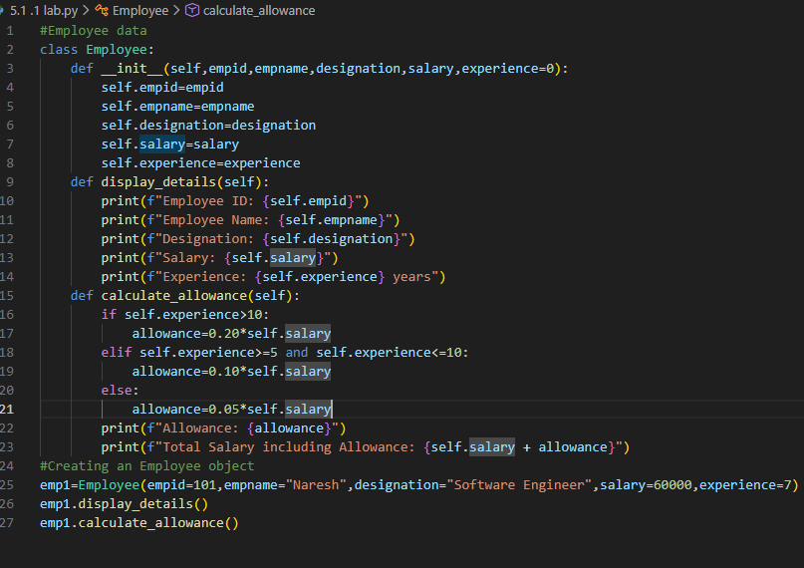

Task 2:
Electricity Bill Calculation- Create Python code that defines a class named `ElectricityBill` with attributes: `customer_id`, `name`, and `units_consumed`. Implement a method
`display_details()` to print customer details, and a method `calculate_bill()` where: Units ≤ 100 → ₹5 per unit
101 to 300 units → ₹7 per unit More than 300 units → ₹10 per unit
Create a bill object, display details, and print the total bill amount.

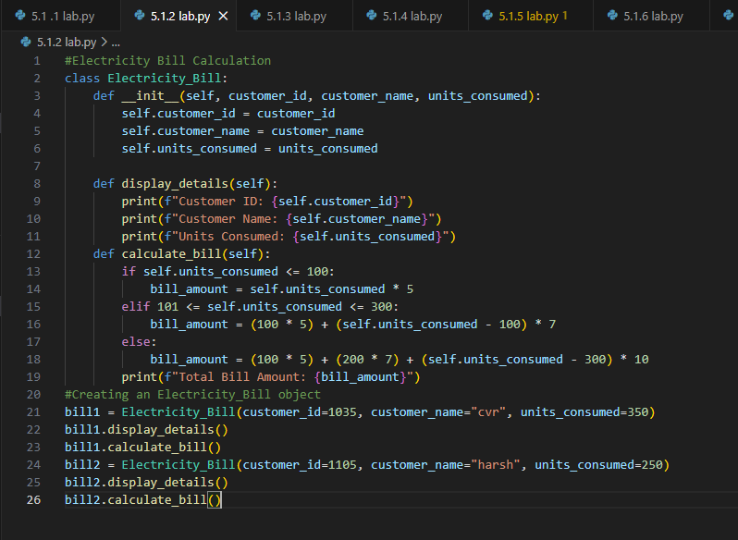

Task 3:
Product Discount Calculation- Create Python code that defines a class named `Product` with attributes: `product_id`, `product_name`, `price`, and `category`. Implement a method
`display_details()` to print product details. Implement another method `calculate_discount()` where:
Electronics → 10% discount Clothing → 15% discount Grocery → 5% discount
Create at least one product object, display details, and print the final price after discount.
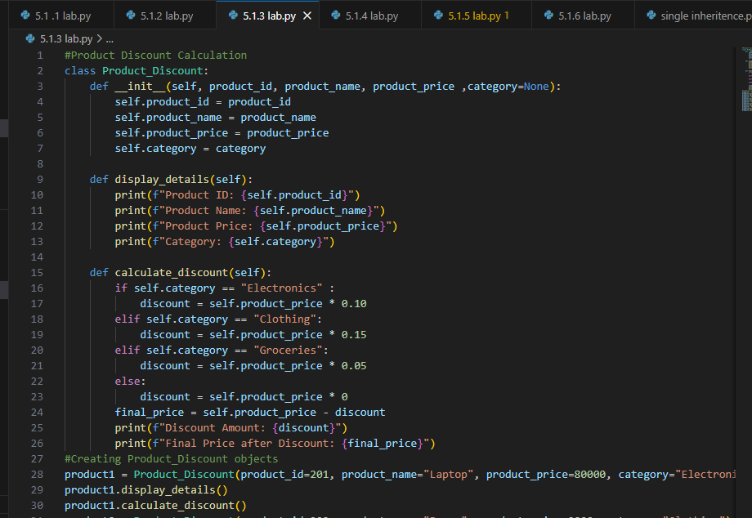

Task 4:

Book Late Fee Calculation- Create Python code that defines a class named `LibraryBook` with attributes: `book_id`, `title`, `author`, `borrower`, and `days_late`. Implement a method
`display_details()` to print book details, and a method `calculate_late_fee()` where: Days late ≤ 5 → ₹5 per day
6 to 10 days late → ₹7 per day
More than 10 days late → ₹10 per day
Create a book object, display details, and print the late fee.
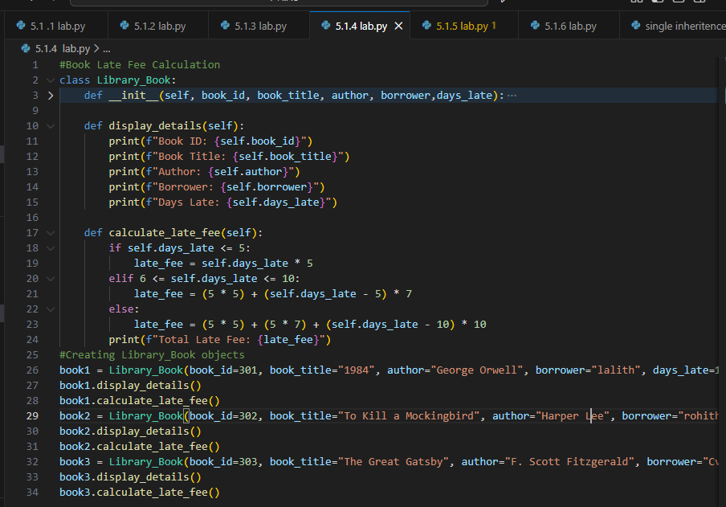

Task 5:
Student Performance Report - Define a function `student_report(student_data)` that accepts a dictionary containing student names and their marks. The function should:
Calculate the average score for each student Determine pass/fail status (pass ≥ 40)
Return a summary report as a list of dictionaries
Use Copilot suggestions as you build the function and format the output.
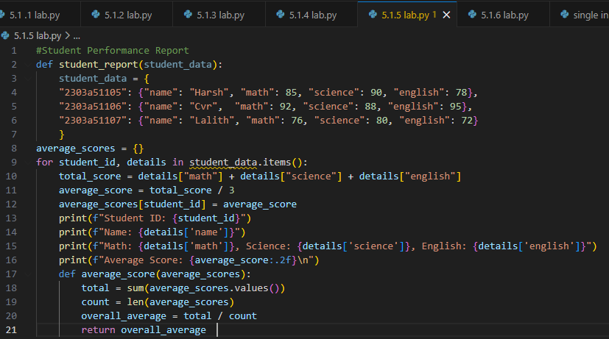

Task 6:

Taxi Fare Calculation-Create Python code that defines a class named `TaxiRide` with attributes:
`ride_id`, `driver_name`, `distance_km`, and `waiting_time_min`. Implement a method
`display_details()` to print ride details, and a method `calculate_fare()` where:
₹15 per km for the first 10 km
₹12 per km for the next 20 km
₹10 per km above 30 km Waiting charge: ₹2 per minute
Create a ride object, display details, and print the total fare.
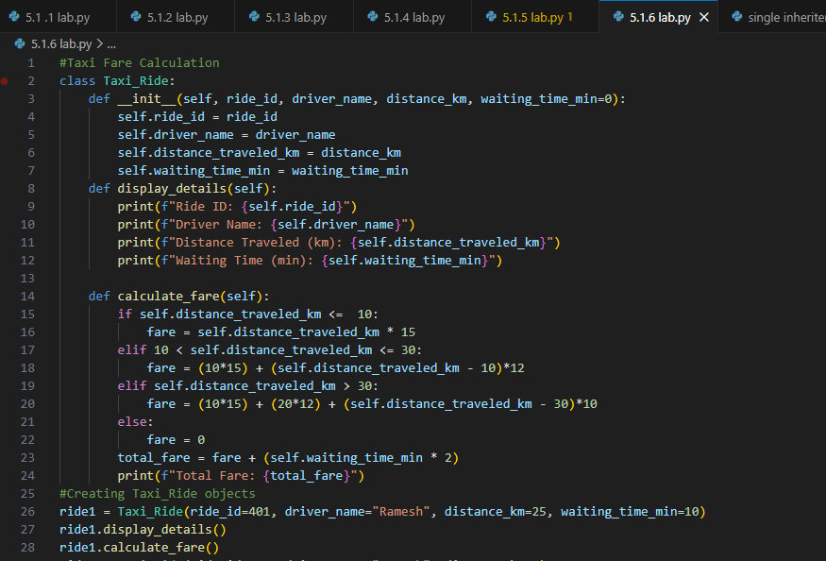

Task 7:
Statistics Subject Performance - Create a Python function `statistics_subject(scores_list)` that accepts a list of 60 student scores and computes key performance statistics. The function should return the following:
Highest score in the class Lowest score in the class Class average score
Number of students passed (score ≥ 40) Number of students failed (score < 40)
Allow Copilot to assist with aggregations and logic

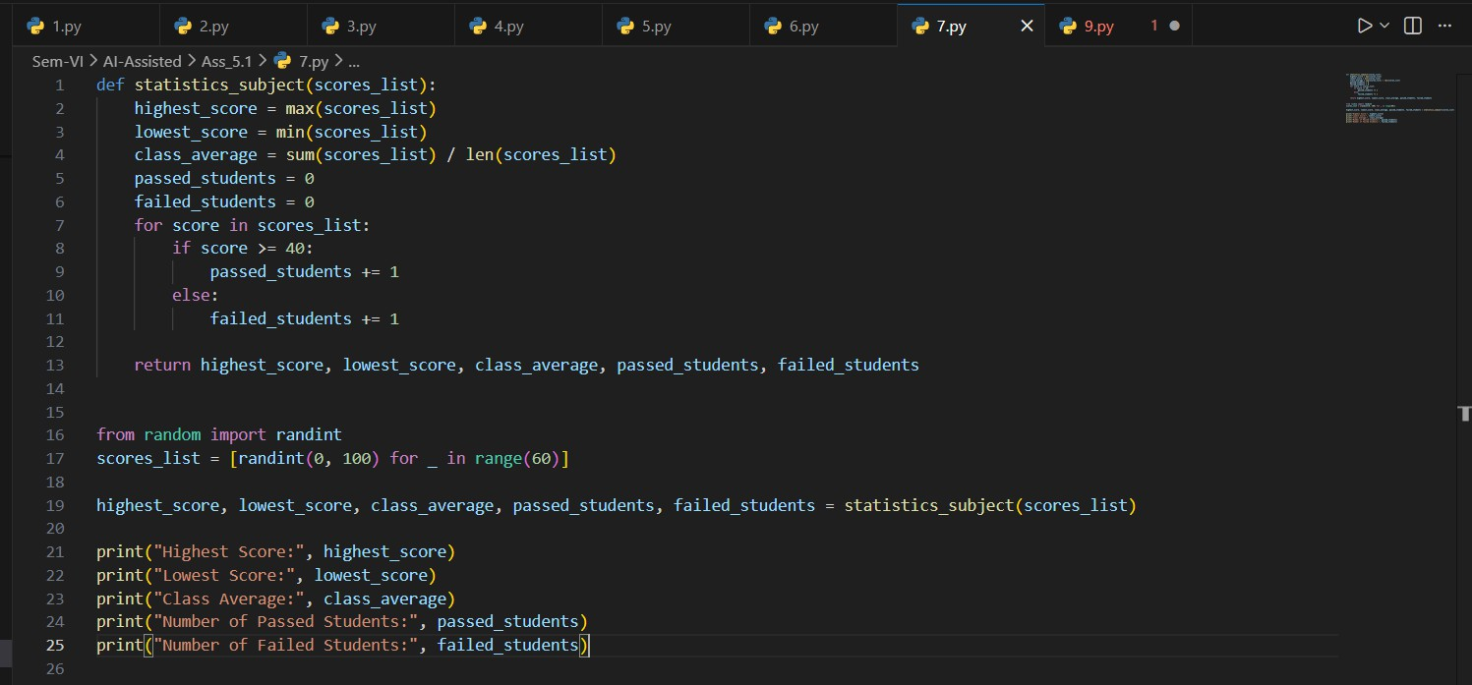

Task 8: (Transparency in Algorithm Optimization) Description:
Use AI to generate two solutions for checking prime numbers:
Naive approach(basic) Optimized approach Prompt:
“Generate Python code for two prime-checking methods and explain how the optimized version improves performance.”
Expected Output:
Code for both methods.
Transparent explanation of time complexity. Comparison highlighting efficiency improvements.

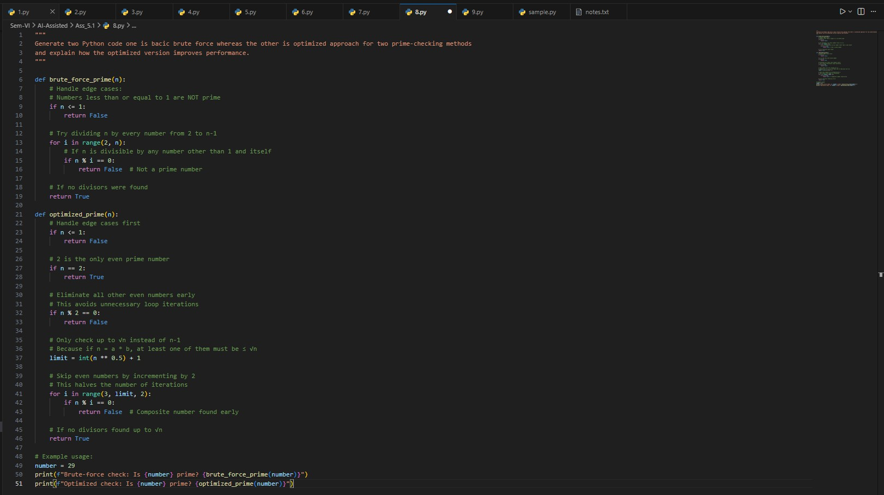

Task 9: (Transparency in Recursive Algorithms)
Objective: Use AI to generate a recursive function to calculate Fibonacci numbers. Instructions:
Ask AI to add clear comments explaining recursion. Ask AI to explain base cases and recursive calls.
Expected Output:
Well-commented recursive code.
Clear explanation of how recursion works.
Verification that explanation matches actual execution.
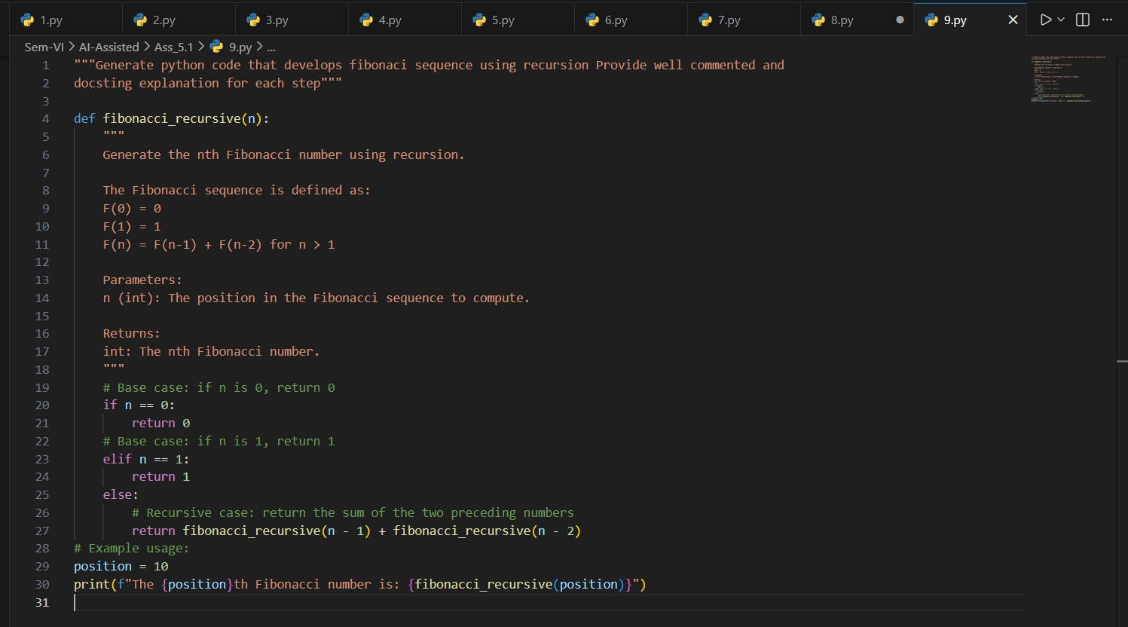

Task 10: (Transparency in Error Handling) Task:
Use AI to generate a Python program that reads a file and processes data. Prompt:
“Generate code with proper error handling and clear explanations for each exception.” Expected Output:
Code with meaningful exception handling.
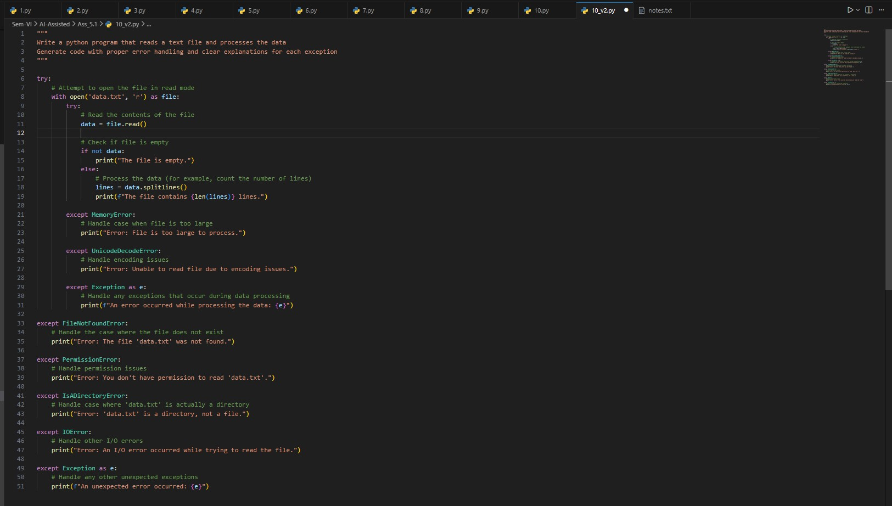
Clear comments explaining each error scenario. Validation that explanations align with runtime behavior.

